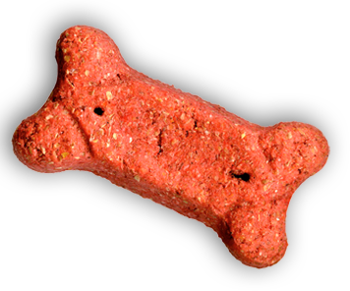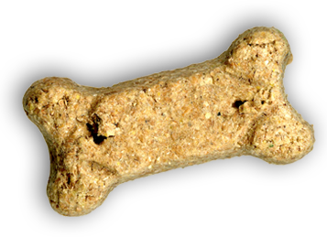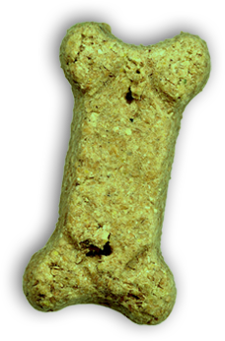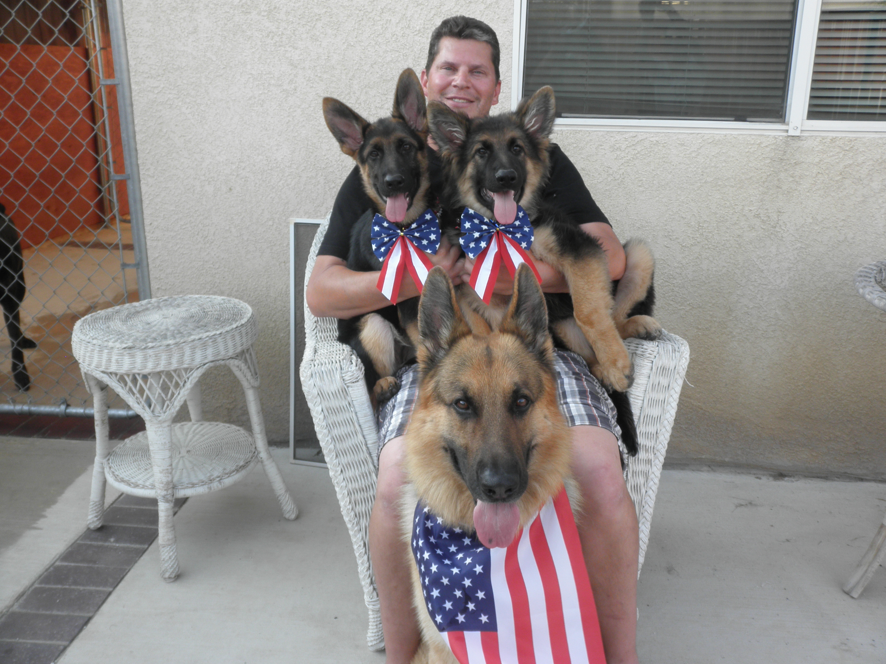



### (951) 333-2901

# LOYAL K-9

# 4th of JULY PARADE

## WHO: Loyal K-9 family, clients and friends

## WHAT: Come and join us in the Moreno Valley 4th of July parade with your dog(s) and be in the parade and on TV.

## WHEN: July 4, 2014 RSVP: By July 1, 2014

## TIME: 7:30AM (check-in), 9:30AM (parade)

## WHERE: North on Frederick St. beginning at Alessandro Blvd., then west on Town Gate Blvd. About a 1-1.5 hour walk.

## **Please no aggressive dogs as they will be in close proximities of each other or on a flat trailer**